**2020**

Er.Mrunal Dilip Wagh

MW Electronics

8/10/2020

AT REPORT

**INTRODUCTON**

**1.1 Problem Statement:-**

This study seek to answer the following questions:

1. What the purpose of making a Smart Gsm based Anti theft System ?
2. What component should be used in the machine to provide simple and inexpensive means to accurately and positively control the comfort?
3. How acceptable is the project, in terms of convenience and efficiency, for the consumers ?
4. What price consumers willing to pay for the commodity?

All the above Questions shows or mentions the problem statement which are expected to be completed through this project and should be efficient and convenient for the consumers.

**1.2 Need of the system:-**.

**Anti**-**theft systems** protect valuables such as motor.

**Its usefull for agriculture**.

**1.3 Objectives of the system:-**

The researchers proposed this study with the following objectives:

1. The primary objective of the project is to Safety of Motor
2. To provide safety.
3. To provide economical, reliable & easy to setup.
4. To determine the acceptability of the study in terms of convenience and efficiency.
5. To determine the acceptable price of the system to the consumer.
6. To able to make an income generating project for the community.

**2.BLOCK DIAGRAM**

**2.1 Block Schematic(s) and Description of System**

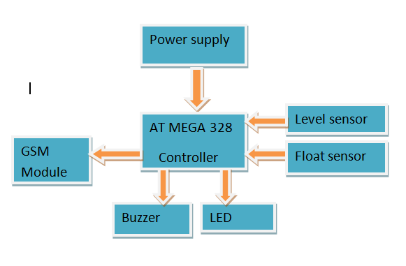

**Fig. 1 Block diagram of system**

**Detailed Description Of Blocks**

The system is hardware and software based system. The system functioning depends on Sensors and Controller. The remaining assembly of basic components.

The block diagram consist of following blocks:-

* ATMega328p controller
* Buzzer
* Gsm module
* Lcd display 16*2

**2.1.1 ATmega328 controller:-**

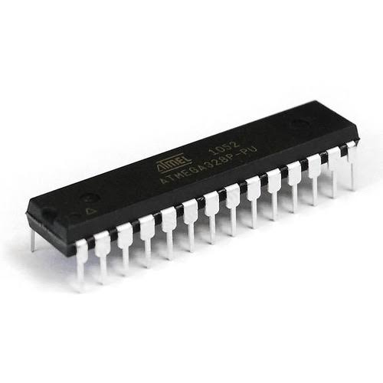

**Fig. 2 ATMega328p IC**

The ATmega48P/88P/168P/328P is a low-power CMOS 8-bit microcontroller based on the AVRenhanced RISC architecture. By executing powerful instructions in a single clock cycle, theATmega48P/88P/168P/328P achieves throughputs approaching 1 MIPS per MHz allowing thesystem designer to optimize power consumption versus processing speed.

The AVR core combines a rich instruction set with 32 general purpose working registers. All the32 registers are directly connected to the Arithmetic Logic Unit (ALU), allowing two independent registers to be accessed in one single instruction executed in one clock cycle. The resulting architecture is more code efficient while achieving throughputs up to ten times faster than conventional CISC microcontrollers.The ATmega48P/88P/168P/328P provides the following features: 4K/8K/16K/32K bytes of In-System Programmable Flash with Read-While-Write capabilities,

256/512/512/1K bytesEEPROM, 512/1K/1K/2K bytes SRAM, 23 general purpose I/O lines, 32 general purpose workingregisters, three flexible Timer/Counters with compare modes, internal and external

interrupts, a serial programmable USART, a byte-oriented 2-wire Serial Interface, an SPI serialport, a 6-channel 10-bit ADC (8 channels in TQFP and QFN/MLF packages), a programmable Watchdog Timer with internal Oscillator, and five software selectable power saving modes. TheIdle mode stops the CPU while allowing the SRAM, Timer/Counters, USART, 2-wire Serial Interface,SPI port, and interrupt system to continue functioning. The Power-down mode saves theregister contents but freezes the Oscillator, disabling all other chip functions until the next interruptor hardware reset. In Power-save mode, the asynchronous timer continues to run, allowingthe user to maintain a timer base while the rest of the device is sleeping. The ADC Noise Reductionmode stops the CPU and all I/O modules except asynchronous timer and ADC, to minimizeswitching noise during ADC conversions. In Standby mode, the crystal/resonator Oscillator isrunning while the rest of the device is sleeping. This allows very fast start-up combined with lowpower consumption.The device is manufactured using Atmel’s high density non-volatile memory technology. TheOn-chip ISP Flash allows the program memory to be reprogrammed In-System through an SPIserial interface, by a conventional non-volatile memory programmer, or by an On-chip Boot programrunning on the AVR core. The Boot program can use any interface to download theapplication program in the Application Flash memory. Software in the Boot Flash section willcontinue to run while the Application Flash section is updated, providing true Read-While-Write operation. By combining an 8-bit RISC CPU with In-System Self-Programmable Flash on a monolithic chip, the Atmel ATmega48P/88P/168P/328P is a powerful microcontroller that provide highly flexible and cost effective solution to many embedded control applications. The ATmega48P/88P/168P/328P AVR is supported with a full suite of program and system development tools including: C Compilers, Macro Assemblers, Program Debugger/Simulators, In-Circuit Emulators, and Evaluation kits.

**Float Sensor**

 float switch is a device used to sense the level of liquid within a tank, it may actuate a pump, an indicator, an alarm, or other device.

A float switch is a device used to sense the level of liquid within a tank. The switch may actuate a pump, an indicator, an alarm, or other device. Use them with hydroponics, saltwater tank, freshwater tank, gardening, aquariums for power head control, pet bowls, fish tanks, filtration, heating, pumps, ponds, basement alarms, boats, air condition drain pans, pressure washers, carpet cleaning mach, reef aquarium, fluid control, ice machines, coffee pots, marine, automotive, automobiles, tropical fish tanks, evaporator coils, condensation line, in relays, or what ever your project may be. It can be easily converted from normally open to normally close by inverting the float.

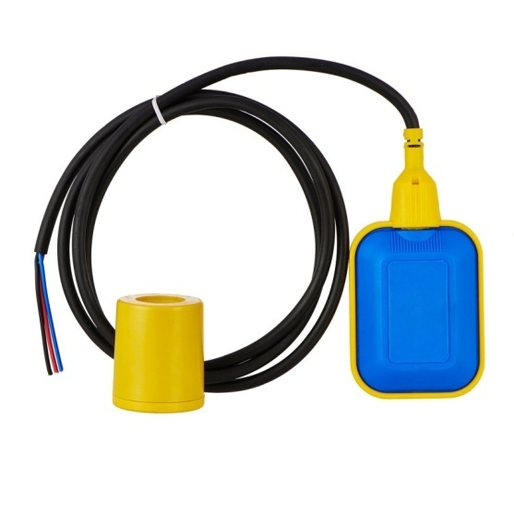

**Specifications:-**

* Cable Length: 30.5(cm)
* Maximum Load: 50 W
* Max Switching Voltage: 100V DC
* Minimum Voltage: 250V DC
* Maximum Switching Current: 0.5 A
* Max Load Current: 1.0 A
* Max Contact Resistance: 0.4 ΩTemp Rating: -20~ 80 degree

**2.2.2**MQ6 SENSOR

MQ6 is a semiconductor type gas sensor which detects the gas leakage. The sensitive

material of MQ-6 is tin dioxide (SnO2). It has very low conductivity in clean air. This Gas

sensor not only has sensitivity to propane and butane but also to other natural gases, the

sensor could be used to detect different combustible gas, especially Methane, it is with low

cost and suitable for different application. The MQ-6 gas sensor is shown in below fig

**Gsm Module**

MQ6 SENSOR

MQ6 is a semiconductor type gas sensor which detects the gas leakage. The sensitive

material of MQ-6 is tin dioxide (SnO2). It has very low conductivity in clean air. This Gas

sensor not only has sensitivity to propane and butane but also to other natural gases, the

sensor could be used to detect different combustible gas, especially Methane, it is with low

cost and suitable for different application. The MQ-6 gas sensor is shown in below fig

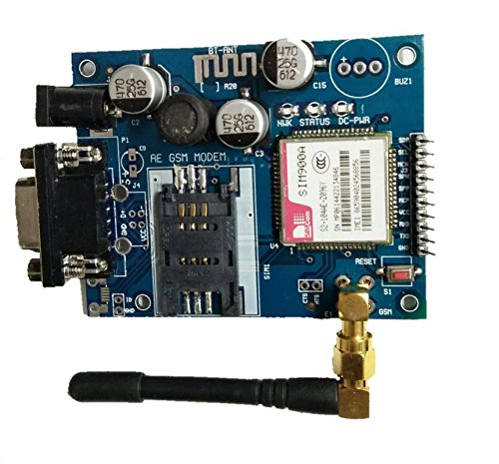

**Sim 800 gsm** + gprs + specifications: **sim800** is a complete quad-band **gsm**/gprs solution in a smt type which can be embedded in the customer applications. **Sim800** support quad-band 850/900/1800/1900mhz, it can transmit voice, sms and data information with low power consumption.

**LCD DISPLAY**

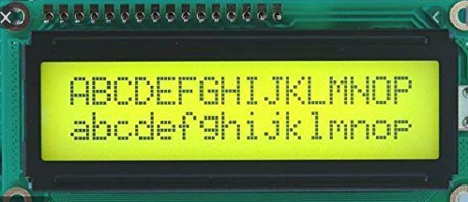

We come across [LCD](https://www.electronicsforu.com/videos-slideshows/videos/building-liquid-crystal-display-lcd) displays everywhere around us. Computers, calculators, television sets, mobile phones, digital watches use some kind of display to display the time. An LCD is an electronic display module which uses liquid crystal to produce a visible image. The 16×2 LCD display is a very basic module commonly used in [DIYs](https://www.electronicsforu.com/category/electronics-projects/hardware-diy) and circuits. The 16×2 translates o a display 16 characters per line in 2 such lines. In this LCD each character is displayed in a 5×7 pixel matrix.

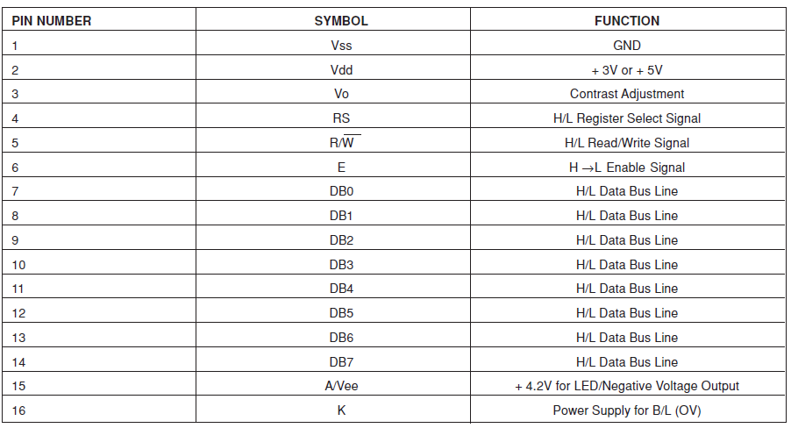

**2.1.5 Buzzer**

The vibrating disk in a magnetic **buzzer** is attracted to the pole by the magnetic field. When an oscillating signal is moved through the coil, it produces a fluctuating magnetic field which vibrates the disk at a frequency equal to that of the drive signal.

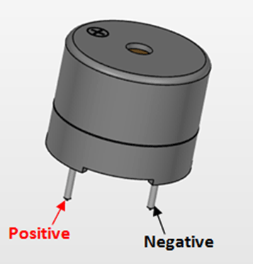

**2.2 Working of system**

The functioning of the circuit when the device is powered ON. First the microcontroller initializes the LCD display and starts reading the analog voltage from the MQ-6 sensor. The MQ5 sensor gas module has 4 pins. Two pins are used for interfacing with developrnent board and other two pins are VCC and ground. Out of two interfacing pins one pin is analog output and other is digital pin. The analog output pin of the module is used for detecting concentration level of gas leakage and interfaced with the A0 analog input pin of the ATmega 328 ic. The analog voltage from the sensor is digitized using the in-built ADC channel and stored in a variable as a 10-bit value.

The 16X2 LCD display is used to display the value of gas concentration. lt is connected to the ATMEGA 328 by connecting its data pins to pins 4to7 of ATMEGA328. The RS and E pins of the LCD are connected to D2 and D3 pins of the AT MEGA. respectively. The RW pin of the LCD is connected to the ground. The sensor value is compared with a calibrated threshold and if the sensor value exceeds that value, the buzzer gets activated. The buzzer is connected to the Dg pin of the MICROCONTROLLER . A 10k potentiometer is also connected to the LCD pin VD, the battery and the ground. This is used for the contrast on the LCD display of the written alphabets or digits. When the leakage of the gas is within a limit or there is no leakage of LPG , the circuit detects and it displays the ADC value or the numerical value which is less than 100. A message showing "LO\[/" keeps on displaying on the LCD screen .The buzzer is kept off for the condition. lf the leakage level is fatal or if the level is at initial stage i.e. there is medium leakage of LPG, the circuit detects and it displays the ADC value, a numerical value greater than 100 and less than 700 on the display. A message showing "YOU ARE SAFE" keeps on displaying on the LCD screen. The buzzer starts alerting by producing a low frequency sound in this condition. lf the leakage level is higher i.e. in the danger level, the circuit detects and it displays the ADC value or the numerical value greater than 300 on the displ?V, ? message showing "LPG GAS LEAKGAE' keeps on displaying on the LCD screen. The buzzer alerts the surrounding by producing a high frequency sound which is audible to all. This is how LPG Gas Leakage Detection circuit works and it alerts when there is high leakage of LPG which is really very dangerous for us. On the LCD screen at that condition

**3.HARDWARE AND SOFTWARE REQUIRMENT**

**3.1 IC’S and Modules and Component Selections**

**3.1.1 Selection Criteria For Microcontroller**

**1.Suitability for the application system —**

* Does it have the required number of I/O (input/output) Pins/ports?
* Does it have all the other required peripherals, such as serial I/O, random-access memory (RAM), read-only memory (ROM), analog-to-digital (A/D), digital-to-analog (D/A), etc.?
* Does it have other peripherals that are not needed?
* Does the CPU (central processor unit) core have the correct Throughput?
* Is the MCU affordable?

**2. Availability?**

* Is the device available in sufficient quantities?
* Is the device in production today?
* What about the future?

**3. Is development support available?**

* Assemblers
* Compilers
* Debugging tools

– Evaluation module (EVM)

– In-circuit emulators

– Logic analyzer pods

– Debug monitors

– Source-level debug monitors

**4. Manufacturer’s history and track record**

* Demonstrated competence in design
* Reliability of silicon; for example, manufacturing excellence
* On-time delivery performance
* Years in business
* Financial report

**3.1 Detail Specifications of IC’s/Modules :**

**3.1.1 ATMega328p Controller** :

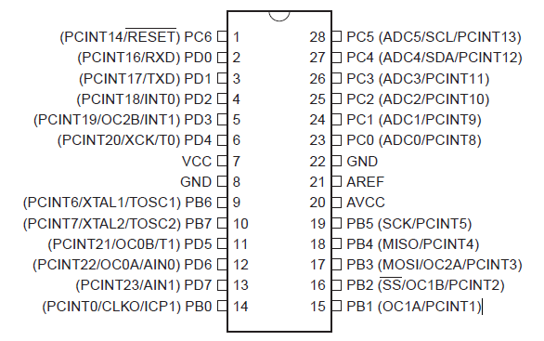

**Fig. 8 pin diagram of ATMega328p**

**Pin Descriptions**

**1. VCC**

Digital supply voltage.

**2. GND**

Ground.

**3. Port B (PB7:0) XTAL1/XTAL2/TOSC1/TOSC2**

Port B is an 8-bit bi-directional I/O port with internal pull-up resistors (selected for each bit). The

Port B output buffers have symmetrical drive characteristics with both high sink and source

capability. As inputs, Port B pins that are externally pulled low will source current if the pull-up

resistors are activated. The Port B pins are tri-stated when a reset condition becomes active,

even if the clock is not running.

Depending on the clock selection fuse settings, PB6 can be used as input to the inverting Oscillator

amplifier and input to the internal clock operating circuit.

Depending on the clock selection fuse settings, PB7 can be used as output from the inverting

Oscillator amplifier.

If the Internal Calibrated RC Oscillator is used as chip clock source, PB7..6 is used as TOSC2..1

input for the Asynchronous Timer/Counter2 if the AS2 bit in ASSR is set.

**4. Port C (PC5:0)**

Port C is a 7-bit bi-directional I/O port with internal pull-up resistors (selected for each bit). The

PC5..0 output buffers have symmetrical drive characteristics with both high sink and source

capability. As inputs, Port C pins that are externally pulled low will source current if the pull-up

resistors are activated. The Port C pins are tri-stated when a reset condition becomes active,

even if the clock is not running.

**5. PC6/RESET**

If the RSTDISBL Fuse is programmed, PC6 is used as an I/O pin. Note that the electrical characteristics of PC6 differ from those of the other pins of Port C.If the RSTDISBL Fuse is unprogrammed, PC6 is used as a Reset input. A low level on this pin

for longer than the minimum pulse length will generate a Reset, even if the clock is not running.

The minimum pulse length is given in Table 26-3 on page 320. Shorter pulses are not guaranteed

to generate a Reset.

**6. Port D (PD7:0)**

Port D is an 8-bit bi-directional I/O port with internal pull-up resistors (selected for each bit). The

Port D output buffers have symmetrical drive characteristics with both high sink and source

capability. As inputs, Port D pins that are externally pulled low will source current if the pull-up

resistors are activated. The Port D pins are tri-stated when a reset condition becomes active,

even if the clock is not running.

**7. AVCC**

AVCC is the supply voltage pin for the A/D Converter, PC3:0, and ADC7:6. It should be externallyconnected to VCC, even if the ADC is not used. If the ADC is used, it should be connected to VCCthrough a low-pass filter. Note that PC6..4 use digital supply voltage, VCC.

**8. AREF**

AREF is the analog reference pin for the A/D Converter.

**9. ADC7:6 (TQFP and QFN/MLF Package Only)**

In the TQFP and QFN/MLF package, ADC7:6 serve as analog inputs to the A/D converter.

These pins are powered from the analog supply and serve as 10-bit ADC channels.

**10.Low Power Crystal Oscillator**

Pins XTAL1 and XTAL2 are input and output, respectively, of an inverting amplifier which can beconfigured for use as an On-chip Oscillator. Either a quartzcrystal or a ceramic resonator may be used.This Crystal Oscillator is a low power oscillator, with reduced voltage swing on the XTAL2 output.It gives the lowest power consumption, but is not capable of driving other clock inputs, andmay be more susceptible to noise in noisy environments.C1 and C2 should always be equal for both crystals and resonators. The optimal value of thecapacitors depends on the crystal or resonator in use, the amount of stray capacitance, and theelectromagnetic noise of the environment . For ceramic resonators, the capacitor valuesgiven by the manufacturer should be used.

**3.1.2. Voltage Regulator IC (LM7805):-**

The KA78XX/KA78XXA series of three-terminal positive regulator are available in tide TO-220/D-PAK package and with several fixed output voltages, making them useful in a range of applications. Each type employs internal current limiting, thermal shut down and safe operating area

protection, making it essentially indestructible. If adequate heat sinking is provided, they can deliver over 1A output current.

Although designed primarily as fixed voltage regulators, these devices can be used with external components to obtain adjustable voltages and currents.

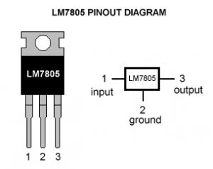

**Fig.9 7805 Pin Diagram**

**Features**

• Output Current up to 1A

• Output Voltages of 5, 6, 8, 9, 10, 12, 15, 18, 24V

• Thermal Overload Protection

• Short Circuit Protection

• Output Transistor Safe Operating Area Protection.

**Specification of voltage regulator IC:-**

|  |  |
| --- | --- |
| **Parameter** | **Rating** |
| Available output DC voltage. | +5V |
| Line regulation. | 0.03 |
| Load regulation. | 0.5 |
| Vin maximum. | 16.16 |
| Ripple rejection. | 60-80db |

**Table I: Specification of voltage regulator IC**

**Electric Parameter**

|  |  |
| --- | --- |
| **Working Voltage** | **DC 5 V** |
| **Working Current** | **15mA** |
| **Working Frequency.** | **40Hz** |
| **Max Range.** | **4m** |
| **Min Range** | **2cm** |
| **MeasuringAngle** | **15 degree** |
| **Trigger Input Signal** | **10uS TTL pulse** |
| **Echo Output Signal** | **Input TTL lever signal and the range in**  **Proportion** |
| **Dimension 45\*** | **45*20*15mm** |

**Table II: Electric Parameter**

**3.2 Software Platform:-**



**Symbol of Arduino IDE**

**Arduino IDE: Initial Setup**

This is the Arduino IDE once it’s been opened. It opens into a blank sketch where you can startprogramming immediately. First, we should configure the board and port settings to allow us to uploadcode. Connect your Arduino board to the PC via the USB cable.

**IDE: Board Setup**

You have to tell the Arduino IDE what board you are uploading to. Select the ​Tools​ pulldown menu andgo to ​Board.​ This list is populated by default with the currently available Arduino Boards that aredeveloped by Arduino. If you are using an Uno or an Uno-Compatible Clone (ex. Funduino, SainSmart,IEIK, etc.), select Arduino Uno. If you are using another board/clone, select that board.

**IDE: COM Port Setup**

If you downloaded the Arduino IDE before plugging in your Arduino board, when you plugged in theboard, the USB drivers should have installed automatically. The most recent Arduino IDE shouldrecognize connected boards and label them with which COM port they are using. Select the ​Toolspulldown menu and then ​Port.​ Here it should list all open COM ports, and if there is a recognizedArduino Board, it will also give it’s name. Select the Arduino board that you have connected to the PC. Ifthe setup was successful, in the bottom right of the Arduino IDE, you should see the board type and COMnumber of the board you plan to program. Note: the Arduino Uno occupies the next available COM port;it will not always be COM3. At this point, your board should be set up for programming, and you can begin writing and uploadingcode.

**Testing Your Settings:**

Uploading BlinkOne common procedure to test whether the board you are using is properly set up is to upload the “Blink”sketch. This sketch is included with all Arduino IDE releases and can be accessed by the ​File​ pull-downmenu and going to ​Examples, 01.Basics, ​and then select ​Blink​. Standard Arduino Boards include asurface-mounted LED labeled “L” or “LED” next to the “RX” and “TX” LEDs, that is connected to digital pin13. This sketch will blink the LED at a regular interval, and is an easy way to confirm if your board is setup properly and you were successful in uploading code. Open the “Blink” sketch and press the “Upload”button in the upper-left corner to upload “Blink” to the board.

**Guide Summary:**

1.Download and install Arduino IDE (​<https://www.arduino.cc/en/Main/Software>)

2.Plug in your Arduino Board

3.Select the proper board in the IDE (​Tools>Boards>Arduino Uno​)

4.Select the proper COM port (​Tools>Port>COMx (Arduino Uno)​)

5.Open the “Blink” sketch (​File>Examples>Basics>01.Blink​)6.Press the Upload button to upload the program to the board

7.Confirm that your board is working as expected by observing LED

Troubleshooting Uploading Errors:

Arduino has lots of community support and documentation. Your best bet when running into unexpectedproblems is to search online for help. You should be able to find a forum where someone had the sameproblem you are having, and someone helped them fix it. If you don’t find results, try modifying yoursearch, or post on the Arduino forums.

●My board isn’t listed under devices and is not recognized by IDE:

○Most likely, this means that the ATMega328p chip is not programmed with the Arduinofirmware. If you have a separate working Uno available, you can program theunprogrammed chip using this guide and a few jumper cables:https://www.arduino.cc/en/Tutorial/ArduinoISP

○If you don’t have a separate Arduino available, let me know and I can use an AtmelProgrammer to upload the firmware.

○There may be hardware damage if you had the board plugged into USB and external powerat the same time. You may have to replace the chip if this is the case.

●Error Message:avrdude: stk500_recv(): programmer is not responding

○Double-check that you are using the correct COM port.

○Make sure that your Arduino Board is plugged into the computer.

●The IDE says “Uploading...” after pressing the upload button, but nothing is happening.

○Double-check that you have the correct board selected in the ​Tools ​menu.

○Depending on the size of your program, it may take a few seconds to upload. If you feel likeit is taking too long, it may be encountering an error and you can try unplugging andplugging in the Arduino bo

**3.3 CODE**

* 1. **Circuit Diagram:-**

**4.2 PCB layout diagram of circuit**

**4.3 Proteus 3D view of circuit**

**Fig.14 3D View Of Circuit**

**.**

**4.3 PCB Design/layout and mounting:-**

**4.3.1 PCB DESIGNING**

**Introduction to PCB:**

Printed circuit boards may be covered in two topics; technology and design. Printed circuit boards are called PCB in short. Printed circuit consists of conductive circuit pattern applied to one or both sides of an insulation base, depending upon that ,it is called single side PCB or double sided PCB(SSB and DSB).Conductor materials like silver, brass, aluminum and copper are most widely used. The thickness of the conducting material depends upon the current carrying capacity of circuit. Thus a thicker copper layer will have more current carrying capacity.

The printed circuit board usually serves three distinct functions:

* It provides mechanical support for the components mounted on it.
* It provides necessary electrical interconnections.
* It acts as a heat sink that is it provides a conduction path leading to removal of most of the heat generated in the circuit.

**4.3.1.1 Manufacturing process of printed circuit board:**

The conductor pattern which is on the master film is transferred on copper clad laminate by two methods:

* Photo resist printing.
* Screen printing.

**4.3.1.2 Photo resist printing:-**

Photopolymer resist is a light sensitive organic material like KPR (Kodak Photo Resist) which is applied to the board as thin film. The photo resist when exposed to ultraviolet light hardens or polymerizes. Once it is polymerized, it becomes insoluble to certain chemical solvents known as developers.

The developer dissolves the portion which is masked or which is not exposed to light. Thus the pattern that is to be drawn on PCB is derived from the artwork which is photographic process. This is transferred to a master film on 1:1 scale. This can be reduced to any small size thus miniaturization is possible. The pattern is transferred to a mask. This mask is kept on PCB. The whole process is known as Image Transfer.

The polymerized or masked portion is washed away in developer leaving wanted copper pattern on board KPR or photo resist is then removed.

**Requirements of photo resists**

* It should have good resolution and light sensitivity.
* It should be resistant to developers which are used to remove unwanted copper.
* It should have possibility to strip after unwanted copper is removed.
* Its cost must be less.

**Photo resist is normally applied by:**

* Flow coating OR
* Roller coating OR
* Dip coating OR
* Spraying

**4.3.1.3 Screen printing:**

This technique is similar to the one used in printing industry. The copper foil is covered with printing ink where the conducting paths are going to be. The screen which is used for pattern is of either stainless steel or polymer mesh which is dimensionally accurate and fine mesh. The open meshes of screen correspond to the pattern.

PCB is placed under the screen. Printing ink is placed at one end of the screen, and by means of a rubber squeegee it is pushed through open meshes. Printed circuit board is then removed for drying. After drying board is washed in ferric chloride which acts as etchant. Etching is chemical process by which unwanted copper is removed. The portion which is covered by ink is not removed, that is the pattern remains intact. Later ink stripping is done with trichloroethylene.

**Protection of copper tracks:**

Copper when exposed to atmosphere for a long time gets tarnished and problems arise at the time of soldering. The tracks can be protected by applying lacquer or varnish depending upon the thickness of the track. Copper is also protected by plating. There are three methods of plating.

Immersion plating

Electro less plating

Electroplating

Immersion plating utilizes tin and its alloys and gold. It is done by chemical replacement from coating material salt solution. This method is simple and less costly. In electro less copper coating electric current is not used. Instead, a chemical reducing agent is used which supplies electrons for reaction in which copper is reduced from its ionic state. In electroplating, a DC current is passed between two electrodes, and a thin coating is deposited on cathode when immersed in electrolyte.

**4.3.1.3 Etching:-**

Removal of unwanted copper, to give final copper pattern is known as etching. Solutions which are used in etching are known as etchants.

Ferric chloride

Cupric chloride

Chromic acid

Alkaline ammonia

Out of these chemicals, ferric chloride is widely used because it has short etching time and it can be stored for a longer time. Rinsing follows etching.

**4.3.1.4 Solders and soldering techniques:**

Solders are special alloys which are used to get either a mechanically strong joint or electric joint of low contact resistance. Solders have low melting points compared to metals to be joined. Therefore when solder is heated, molten solder wets the metal, spreads and joints. Any contamination on the surface of the metal to be joined acts as a paired and hampers the action of wetting. Solders are divided into two groups, soft and hard. Soft solders have lower melting point and lower tensile strength. Soft solders are largely tin lead alloys and silver based compositions. Fluxes are auxiliary materials used while soldering is done. They dissolve and remove oxides and contaminants from surface of metals to be soldered. They protect the metal surface and molten solder from oxidation. They reduce the surface tension of molten solder. They improve the ability of solder to wet the metal. Active or acid fluxes: they are prepared on the basis of active substances, such as hydrochloric acid, chlorides and fluorides of metals, etc. these fluxes intensively dissolve oxide films on the metal surface and thus make for better adhesion of the solder to the base metal, the residue must be thoroughly removed after soldering. Active fluxes are not used in soldering the circuit wires of radio devices.

**5.SYSTEM WORK-FLOW DESCRIPTION**

**5.1 Working of System**

**6. TESTING AND RESULT**

**6.1 Testing:**

Testing is nothing but the physical checking of the all components and all possible condition to avoid problem in the circuit functioning. Testing done with so many checking as per the circuit requirement and conditions.

**6.1.1 Before Soldering In Components:**

* Check that components agree with the part list (value and power of resistors, value and voltage rating of capacitor, etc.) if in any doubt double check the polarized components (diodes, capacitors resistors, etc.).
* If there is a significant time elapse between circuits, take trouble to read the article; the information is often give in a very condensed form. Try to get most important point out of the description of the circuit. Even if you don’t understand exactly what is supposed to happen.
* If there is any doubt that some component may not may be equivalent, check that they are compatible.
* Only used good quality IC socket.
* Check the continuity if the track on the PCB (and through plated holes with the double sided boards) with resistance of continuity tester.
* Make sure that all drilling, filling and other ‘heavy’ work is done mounting any components.
* If possible keep any heat sinks well isolated from other components.
* Make wiring diagram if the layout involves lots of wires spread out in all directions.
* Check that the connectors used compatible and that they are mounted the right way round.
* Do not reused wire unless it is of good quality. Cut off the ends and strip it a new.

**6.1.2 After Mounting The Components:**

* Inspect all the solder joints by are using a magnifying glass the check them with a continuity tester. Make sure there are no dry joints no tracks are short circuited by poor soldering.
* Ensure that the positions of all the components agree with the mounting diagram.
* Check that any links needed are present and that they are in right positions to give desired configurations.
* Check all the IC’s in their sockets (see that there are no pins bent under any IC’s no near IC’s are interchanged etc)
* Check all polarized components (diodes, capacitors etc) are fitted correctly.
* Check the wiring (watch for off cuts of components leads)at the same time ensure that there are not short circuits between potentiometer ,switches etc. and there immediate surrounding (other components or the case).do the same with mounting hardware such as spacers, nuts and bolts etc)
* Ensure that the supply transformer is located as closely as possible to the circuits (this could for significant improvement in the case of critical signal level).
* Check that the connections to the earth are there and that they are of good contact.
* Make sure the circuit is working correctly before spending any time putting it into a case. And if it breaks down
* Recheck everything suggested too far.
* Re-read the article carefully and carefully anything about which you are doubtful.
* Check the supply voltage or voltages carefully and make sure that they reach appropriate components especially pins of the IC’s (test the pins of IC’s and not the soldered joints).
* Check currents (generally they are state on circuit diagram or in the text.

**6.2 Result**

After the PCB is prepared the conductivity test is carried out. First pin-to-pin conductivity is checked. The necessary IC interconnections are also checked. The resistance value of all the resistor are checked and then completed with the value denoted by color-coding is done.

The capacitors are also checked to see whether they are working or short or open. The diodes are tossed for priority. The diodes are cracked for their forward resistance and reverse resistance. After carrying out all the possible testing, the jumper wires are also tested for conductivity.

**6.3 Snapshot**